Speedometer
# Source: AI Source: Provided by: [Data Path: Persons Table -> ID Column: 1, Name_En Column: Motasem Essam] -> From: [ChatGPT] on [7/17/2026]
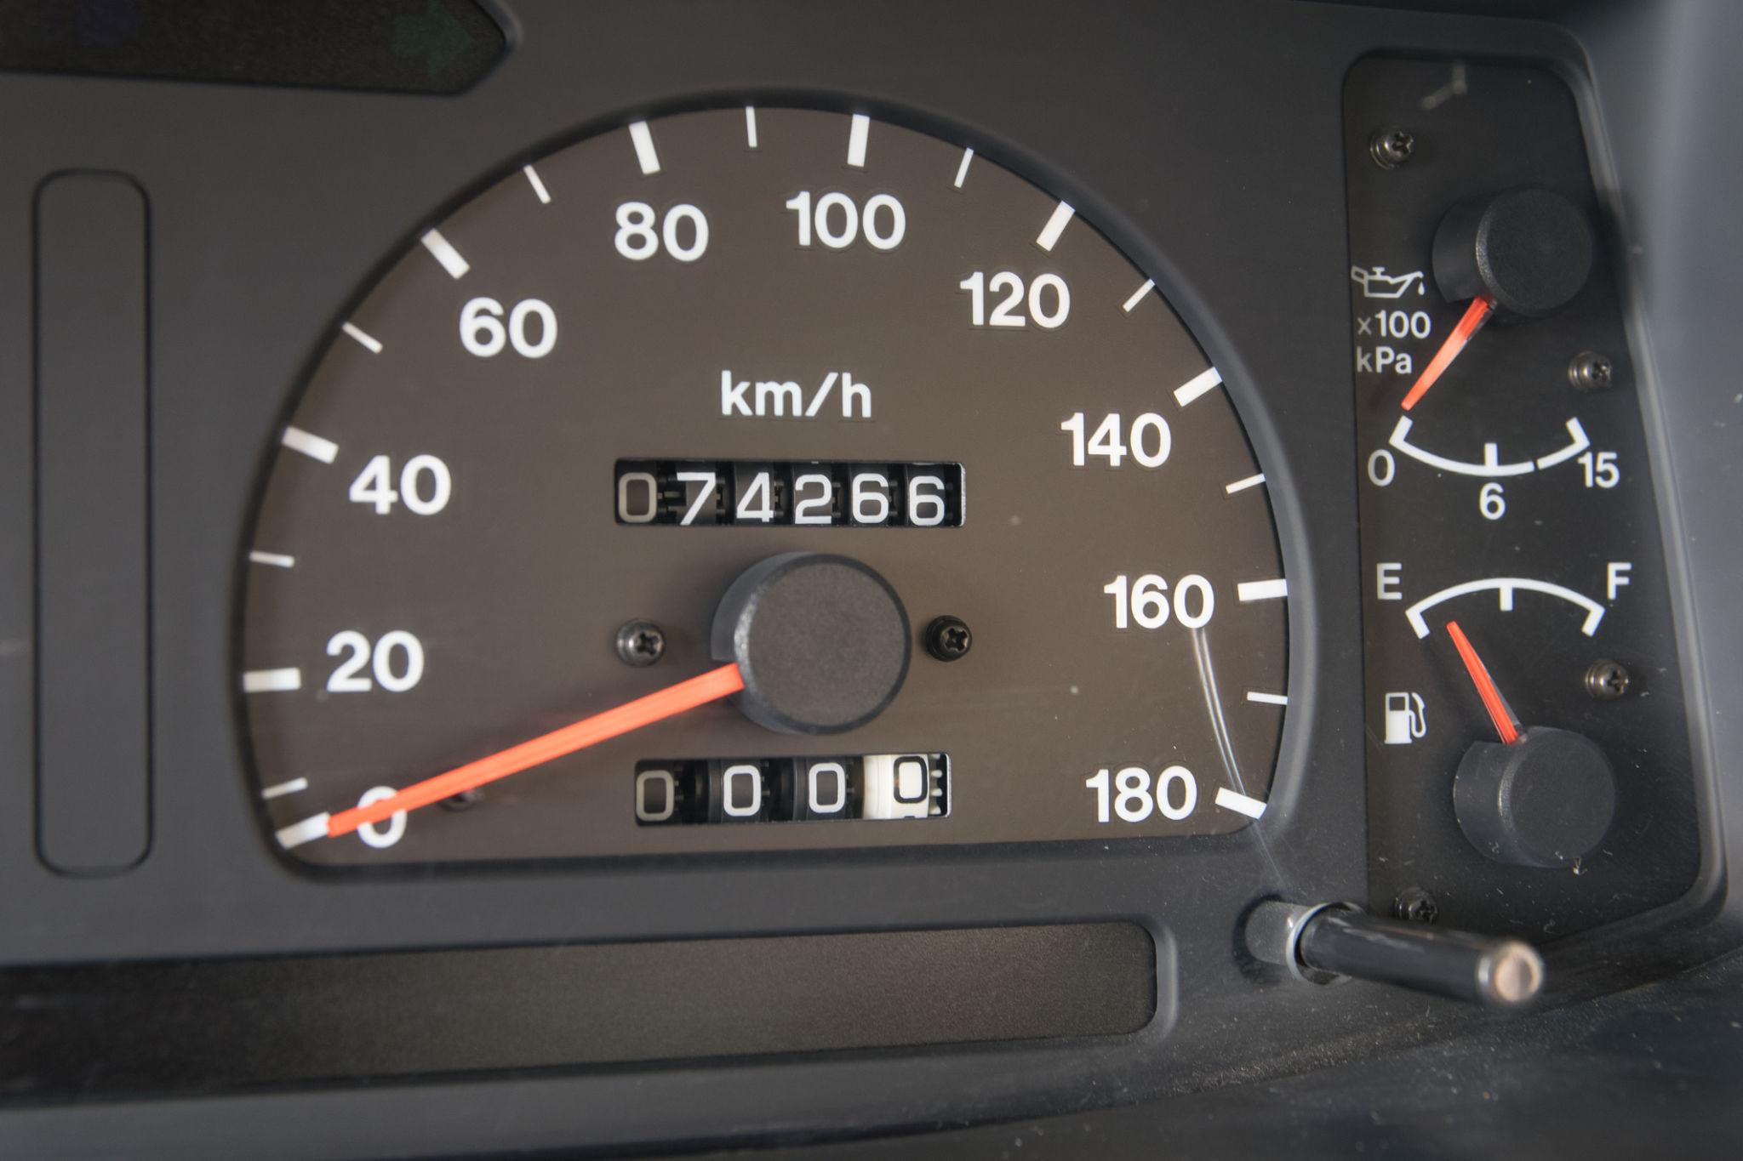
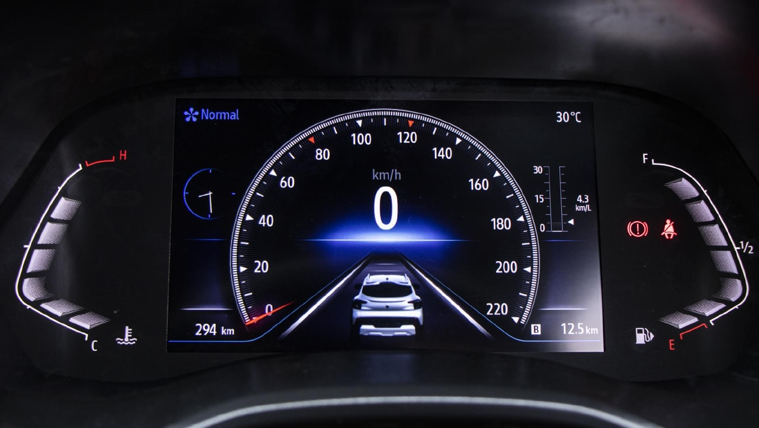
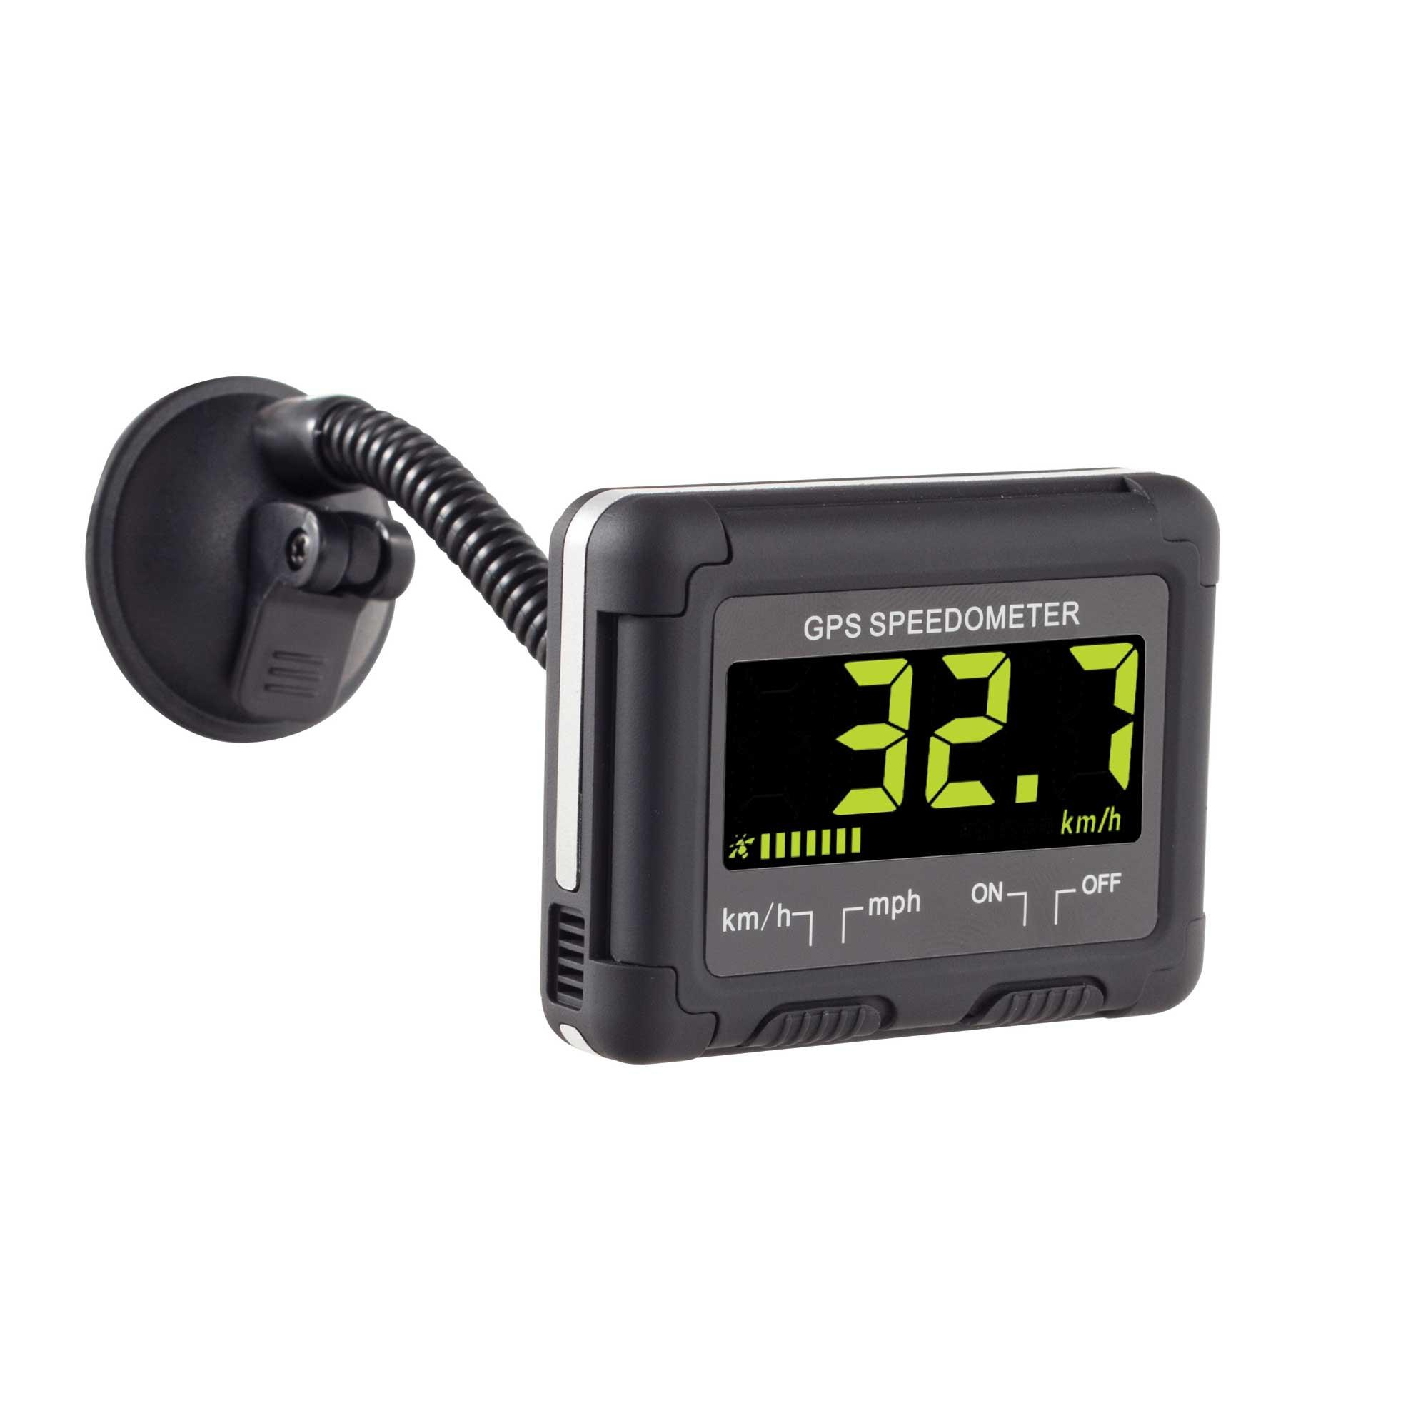
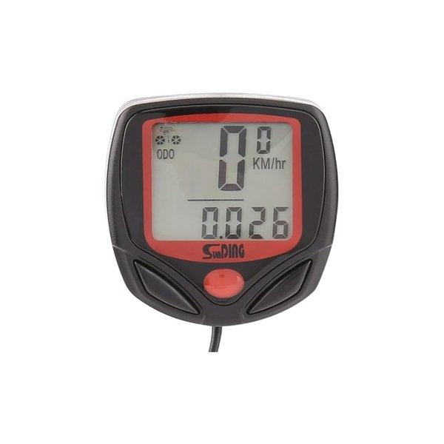
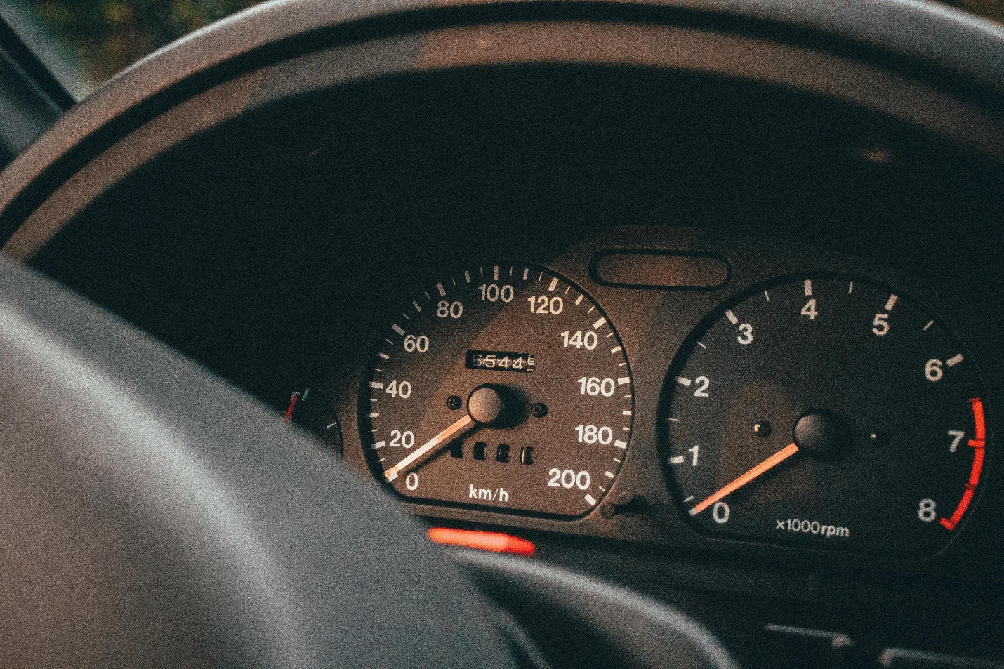
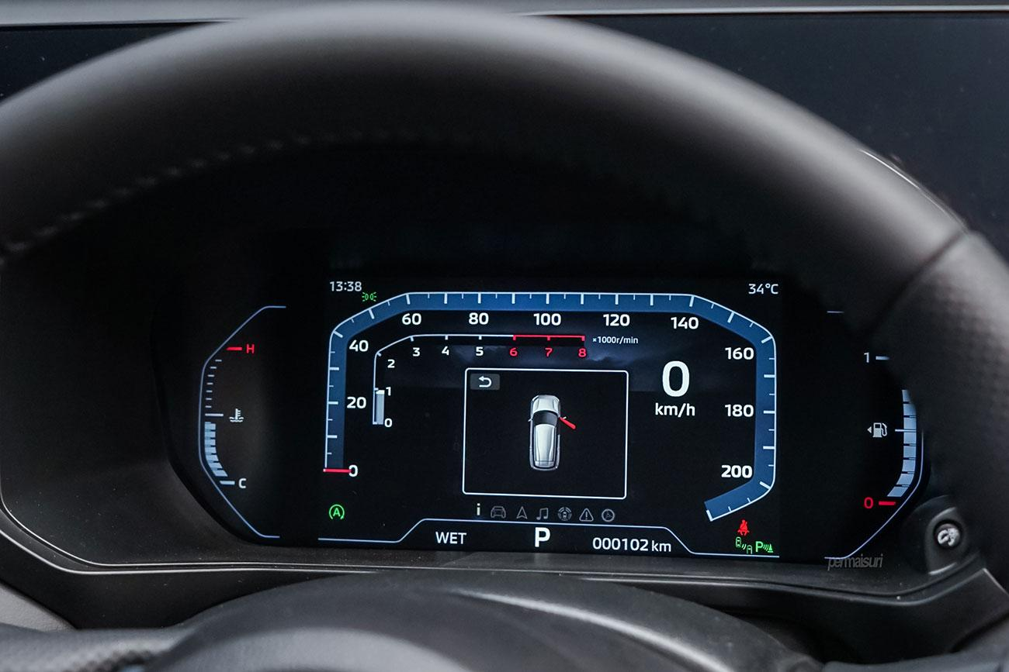
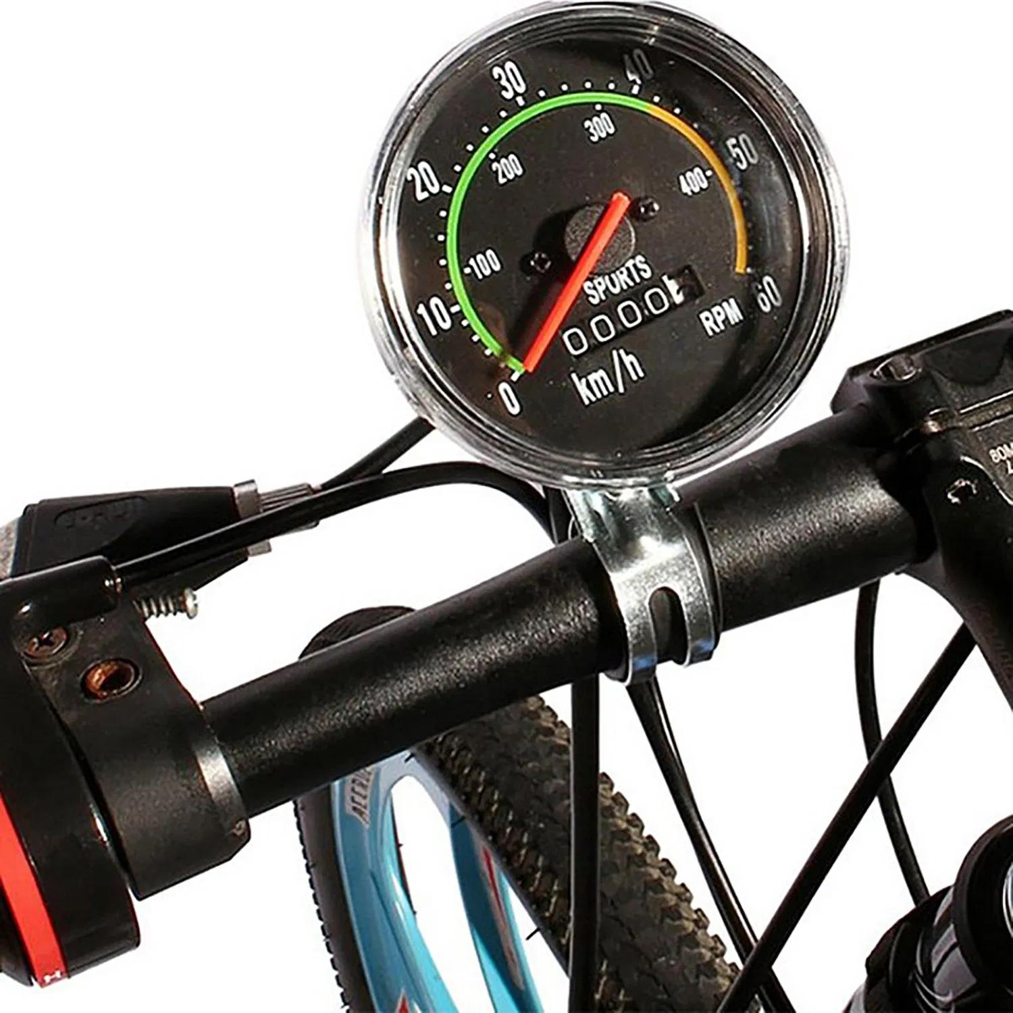
A Speedometer is a speed-measuring instrument used to determine and display the instantaneous speed of a moving vehicle. It is commonly installed in cars, motorcycles, trucks, buses, bicycles, boats, and aircraft, providing real-time speed information to the operator.
Modern speedometers may operate mechanically, electronically, or using Global Positioning System (GPS) technology.

Definition
# Source: AI Source: Provided by: [Data Path: Persons Table -> ID Column: 1, Name_En Column: Motasem Essam] -> From: [ChatGPT] on [7/17/2026]
A Speedometer is an instrument that measures and displays the instantaneous speed of a moving vehicle relative to the ground or another reference.

Purpose
# Source: AI Source: Provided by: [Data Path: Persons Table -> ID Column: 1, Name_En Column: Motasem Essam] -> From: [ChatGPT] on [7/17/2026]
A speedometer is used to:
- Measure vehicle speed.
- Help drivers obey speed limits.
- Improve driving safety.
- Monitor vehicle performance.
- Support navigation.
- Assist in fuel-efficient driving.

Principle of Operation
# Source: AI Source: Provided by: [Data Path: Persons Table -> ID Column: 1, Name_En Column: Motasem Essam] -> From: [ChatGPT] on [7/17/2026]
The operating principle depends on the type of speedometer.
Mechanical Speedometer
Uses a rotating cable connected to the vehicle's transmission. The rotation drives a magnetic mechanism that moves the pointer.
Electronic Speedometer
Uses wheel-speed sensors or transmission sensors to measure rotational speed and convert it into vehicle speed.
GPS Speedometer
Calculates speed by measuring changes in geographic position over time using satellite signals.

Main Components
# Source: AI Source: Provided by: [Data Path: Persons Table -> ID Column: 1, Name_En Column: Motasem Essam] -> From: [ChatGPT] on [7/17/2026]
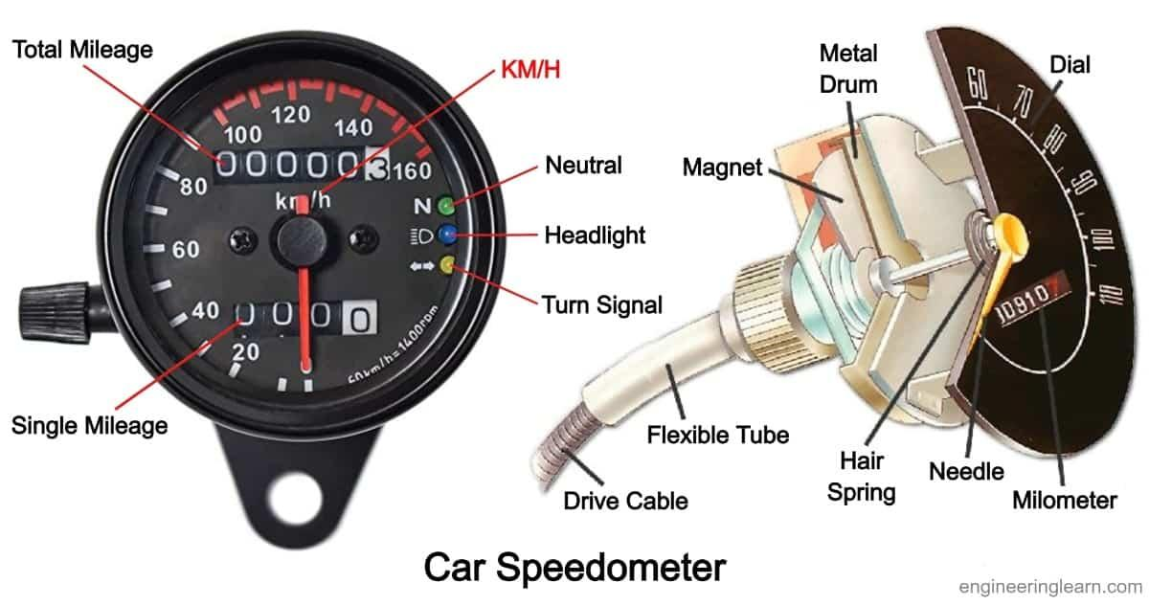
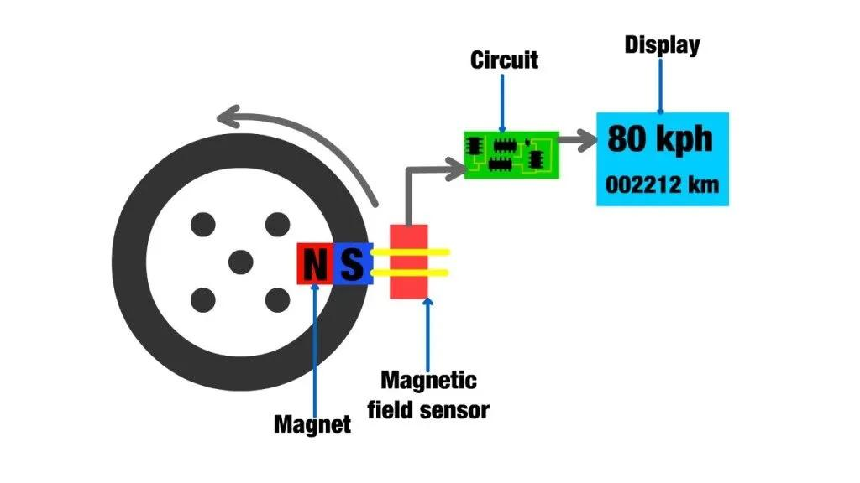
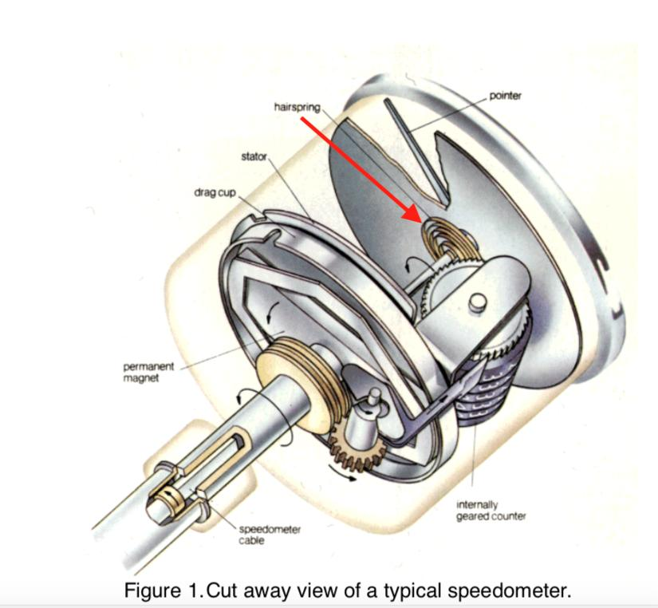
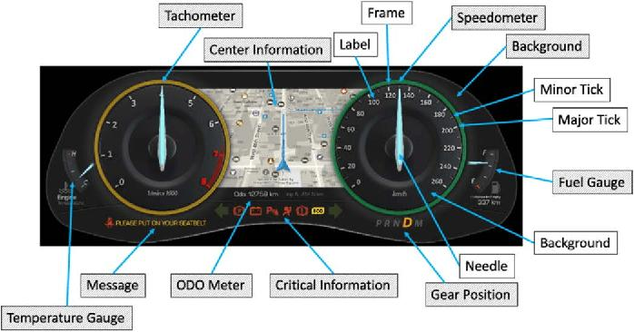
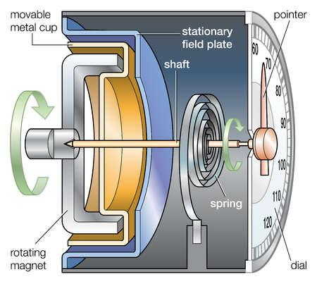
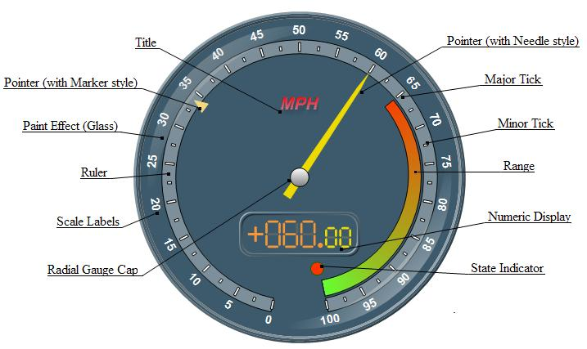
A typical speedometer consists of:
- Speed sensor
- Electronic control circuit
- Display (analog or digital)
- Pointer (analog models)
- Graduated speed scale
- Power supply
- Vehicle communication interface

Types of Speedometers

1. Mechanical Speedometer
# Source: AI Source: Provided by: [Data Path: Persons Table -> ID Column: 1, Name_En Column: Motasem Essam] -> From: [ChatGPT] on [7/17/2026]
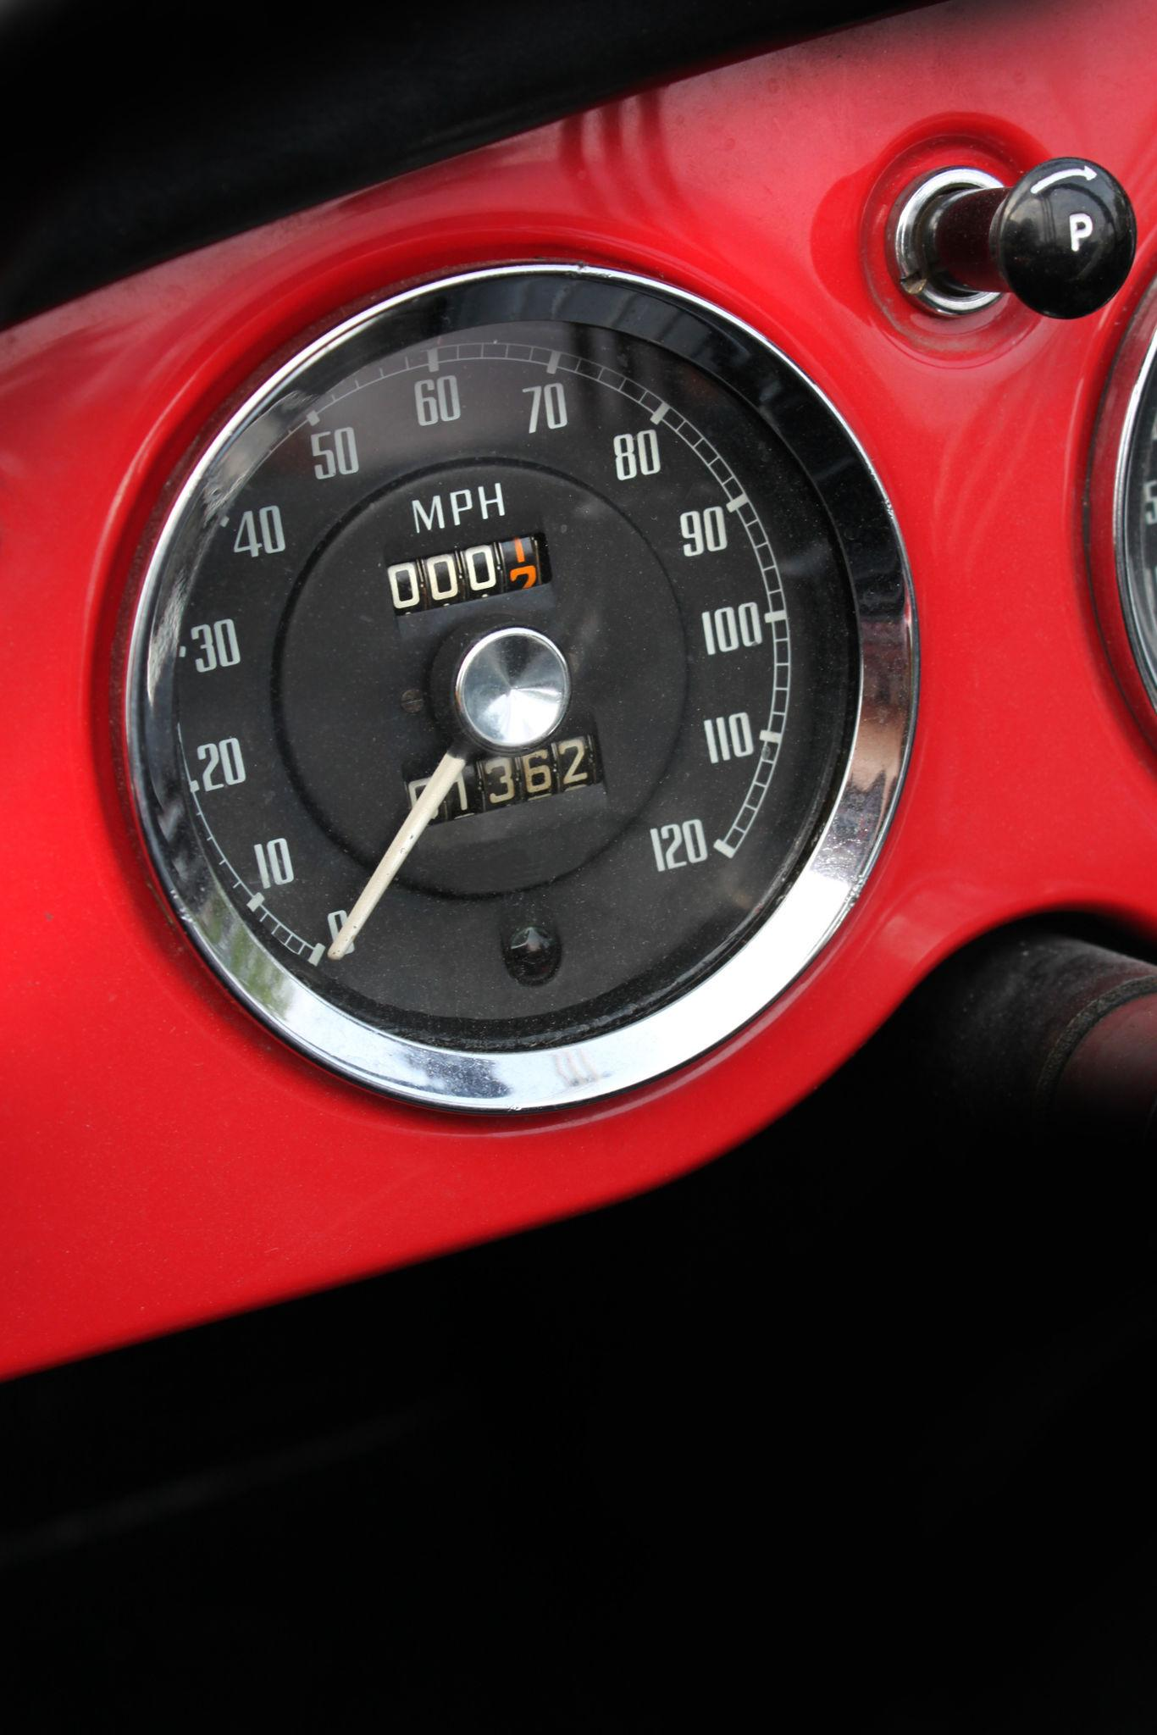
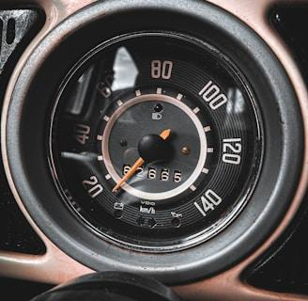
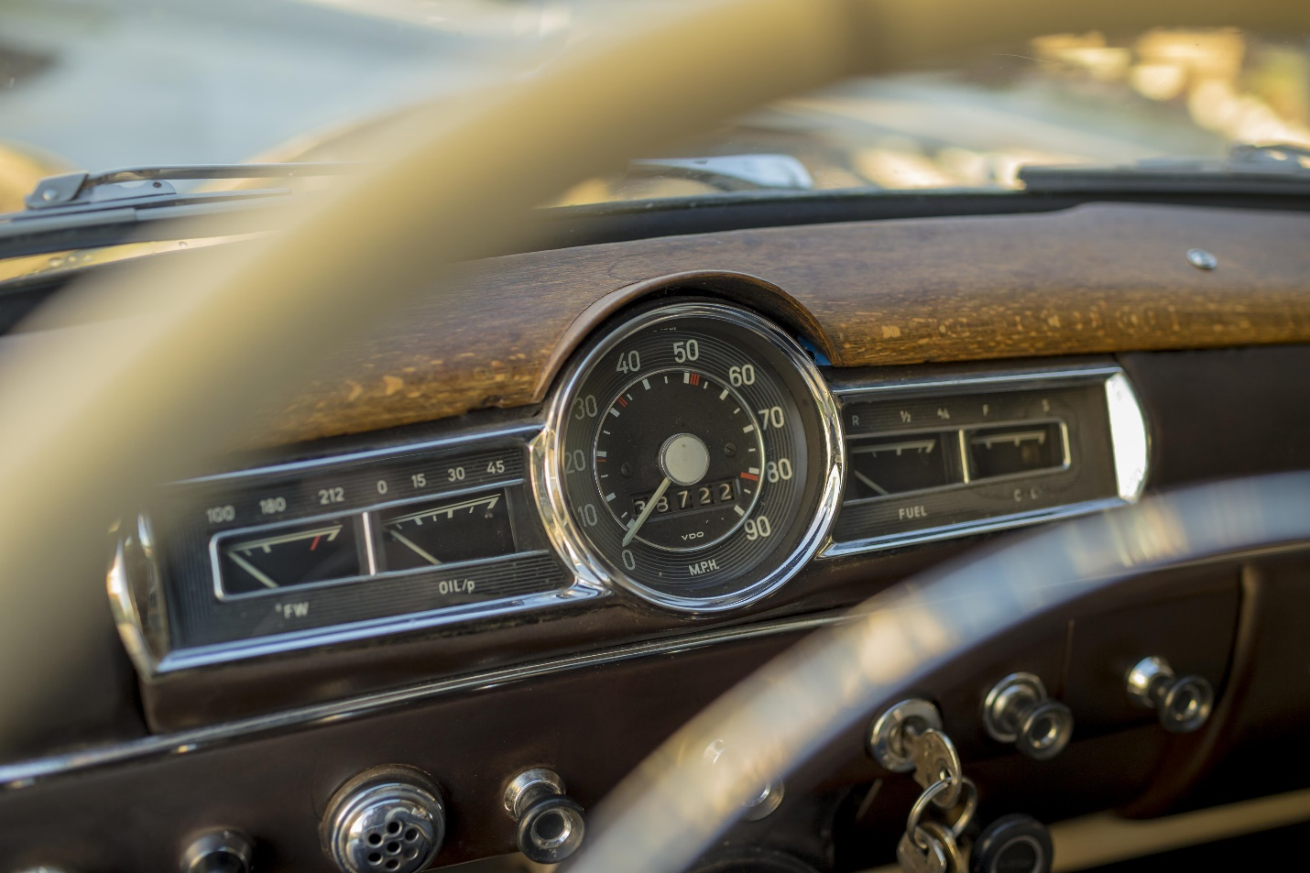
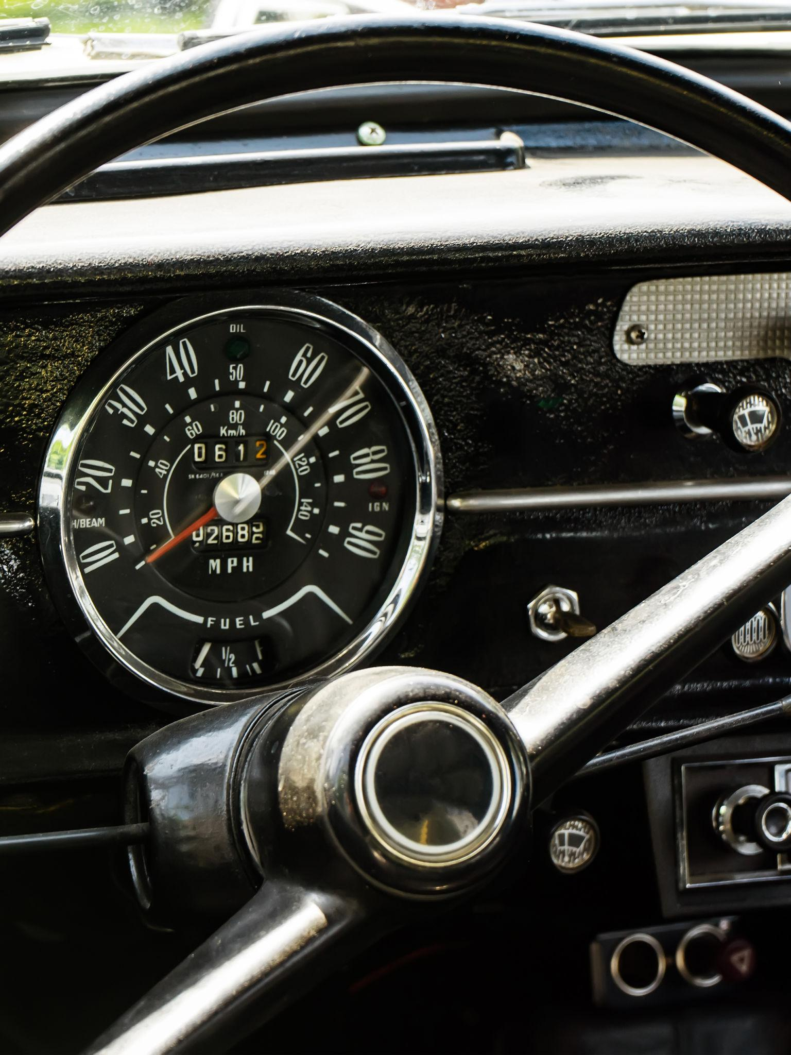
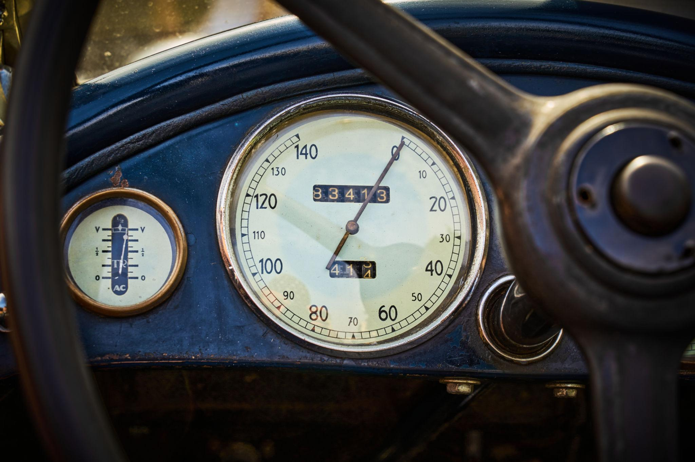
Description
Uses a rotating cable connected to the vehicle's transmission. The cable drives a magnetic mechanism that moves an analog pointer over a graduated scale.
Features
- Analog display
- Cable-driven
- Magnetic mechanism
- No electronic circuitry
Applications
- Vintage cars
- Classic motorcycles
- Older trucks

2. Electronic Speedometer
# Source: AI Source: Provided by: [Data Path: Persons Table -> ID Column: 1, Name_En Column: Motasem Essam] -> From: [ChatGPT] on [7/17/2026]
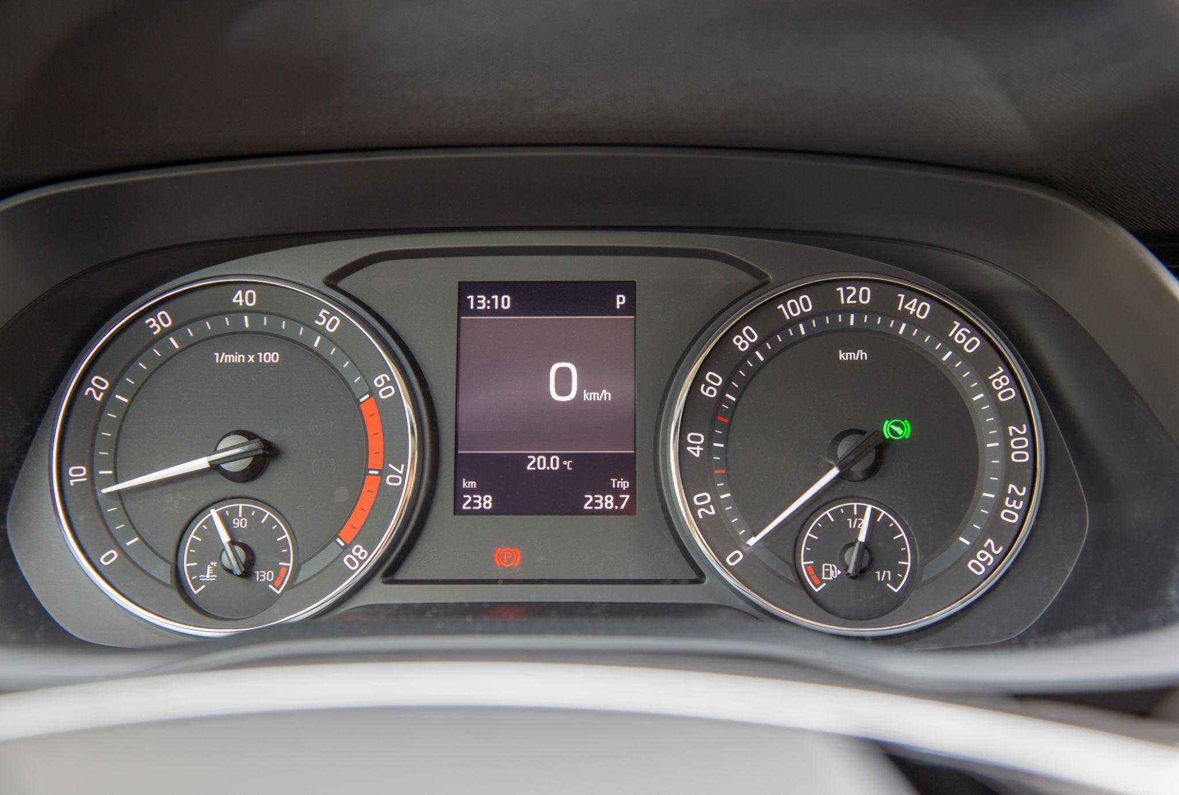
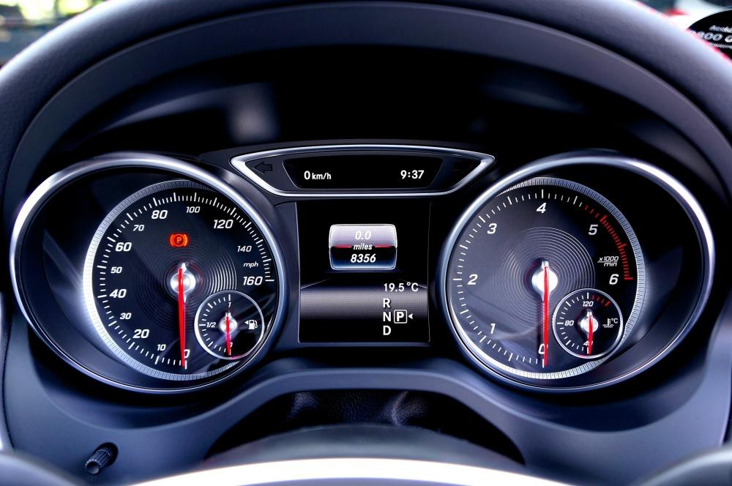
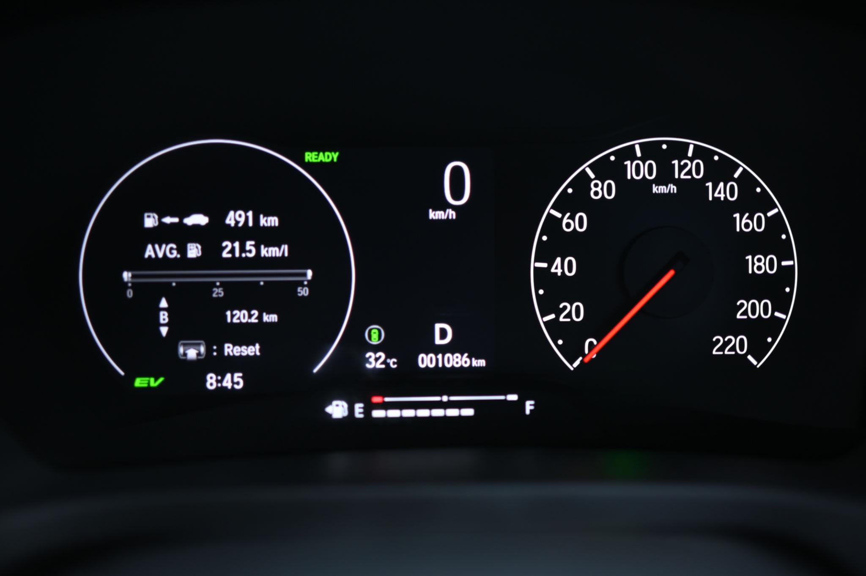
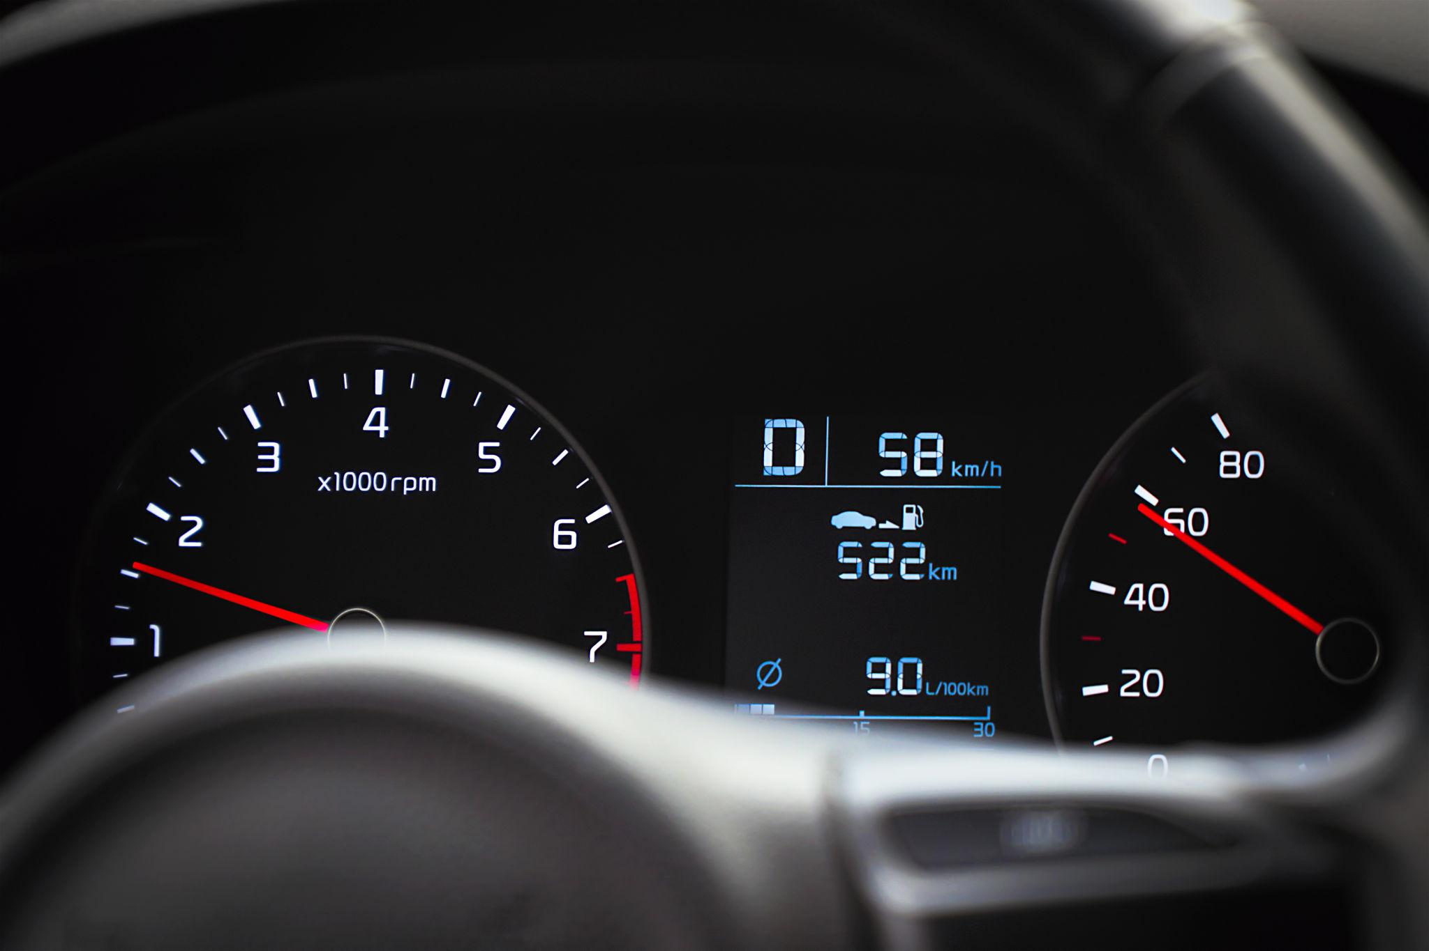
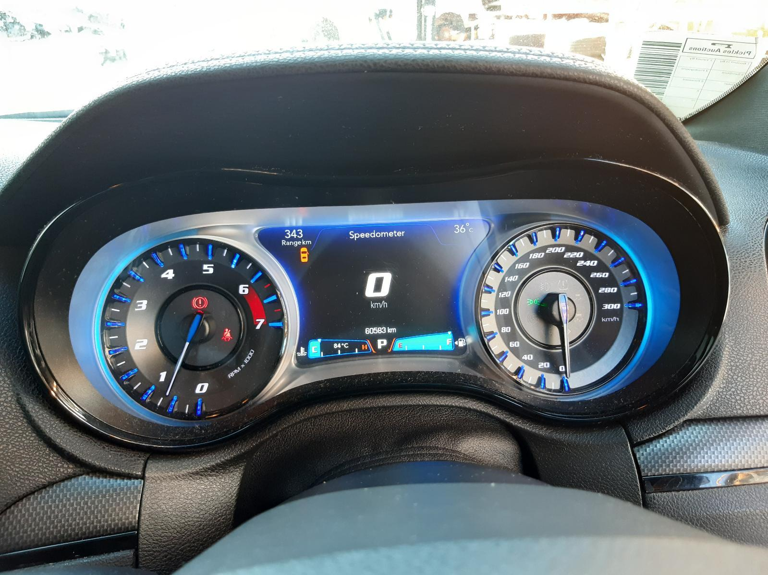
Description
Measures vehicle speed using electronic sensors mounted on the transmission or wheels while displaying the speed with an analog pointer.
Features
- Electronic sensors
- Analog-style display
- Higher reliability than mechanical systems
Applications
- Modern passenger cars
- Trucks
- Motorcycles

3. Digital Speedometer
# Source: AI Source: Provided by: [Data Path: Persons Table -> ID Column: 1, Name_En Column: Motasem Essam] -> From: [ChatGPT] on [7/17/2026]

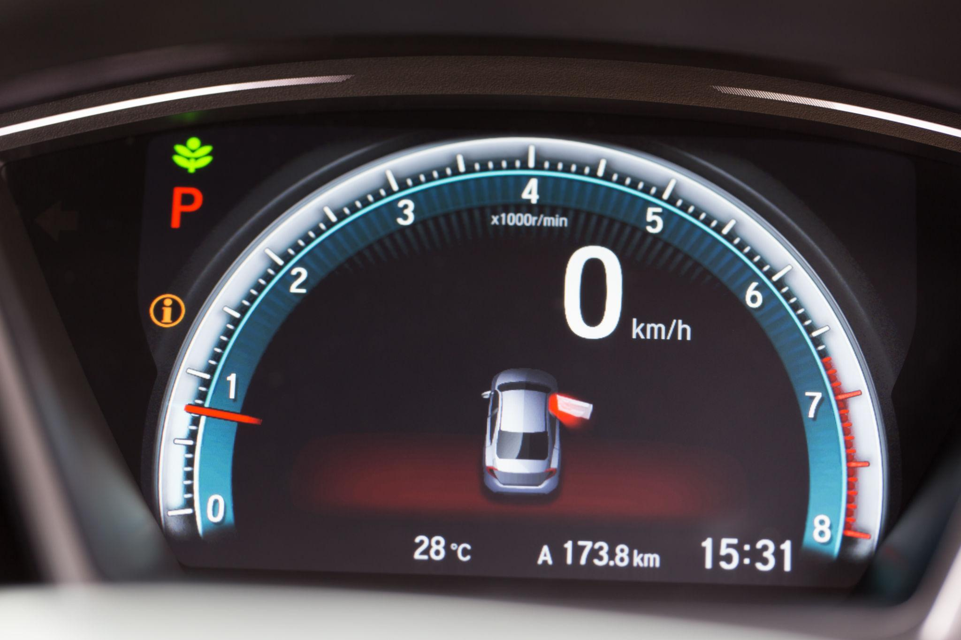
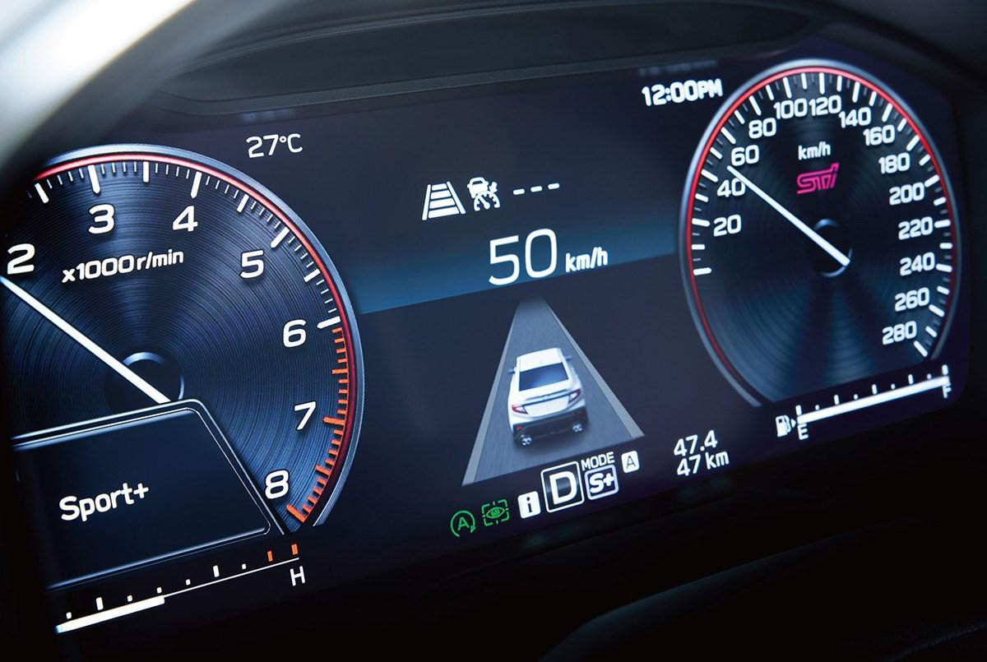
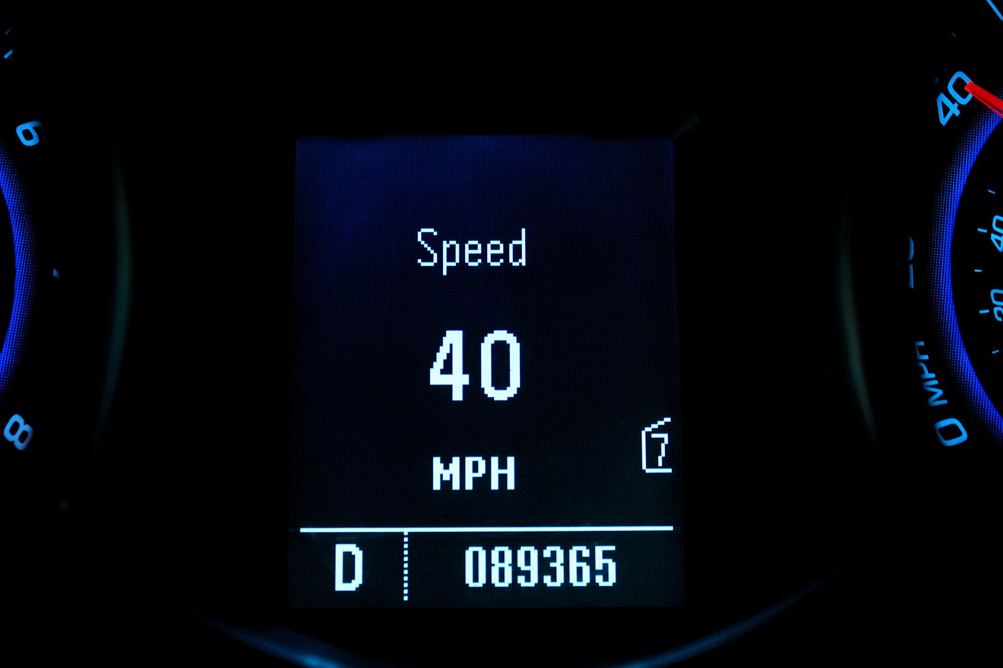
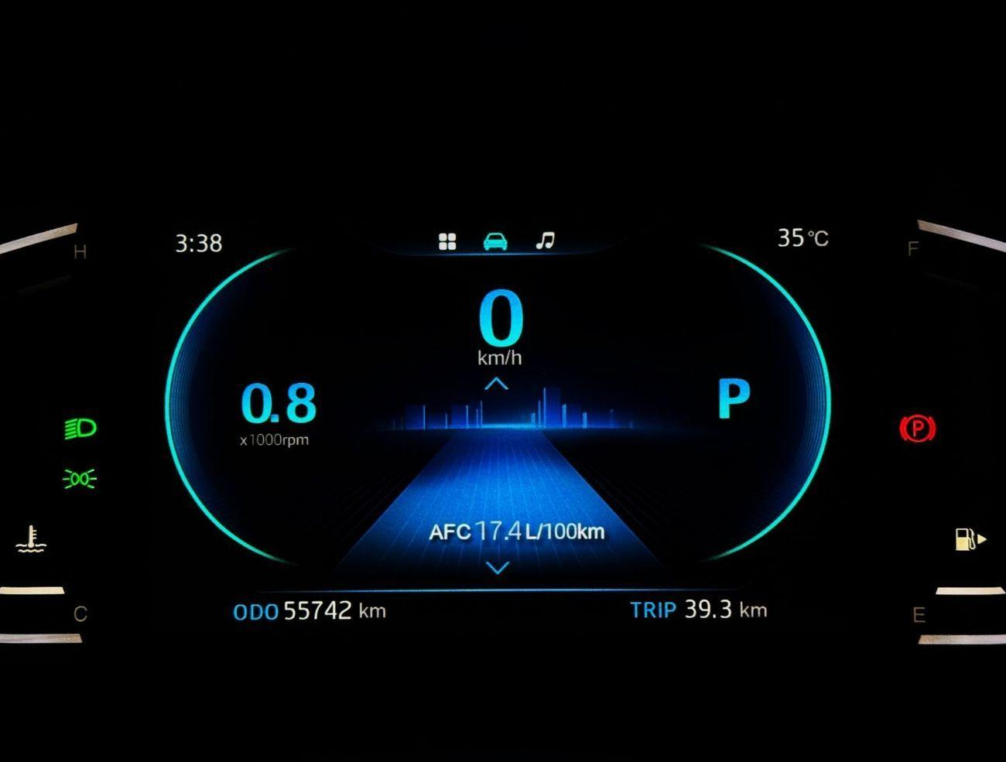
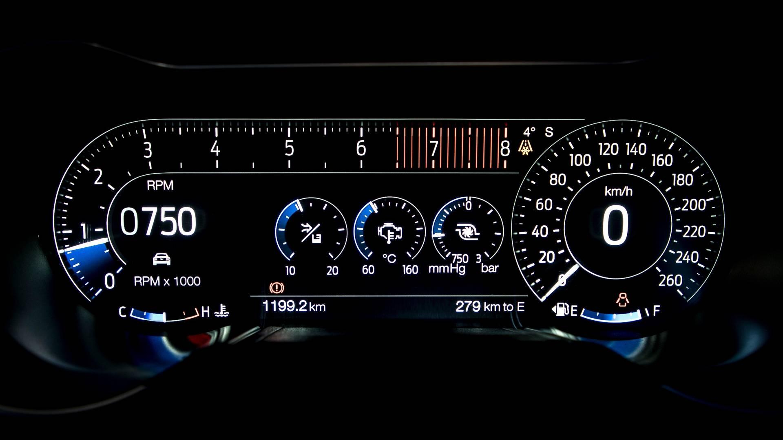
Description
Displays vehicle speed numerically on an LCD, LED, or TFT display.
Features
- Digital numeric display
- Easy to read
- High precision
- Often integrated into digital instrument clusters
Applications
- Modern automobiles
- Electric vehicles
- Motorcycles

4. GPS Speedometer
# Source: AI Source: Provided by: [Data Path: Persons Table -> ID Column: 1, Name_En Column: Motasem Essam] -> From: [ChatGPT] on [7/17/2026]
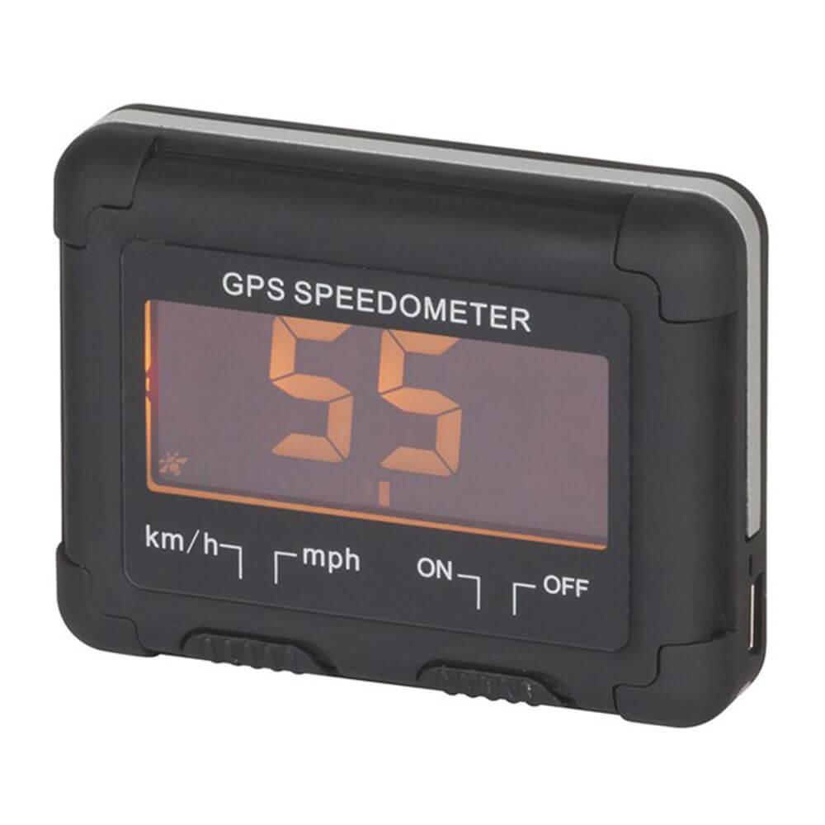

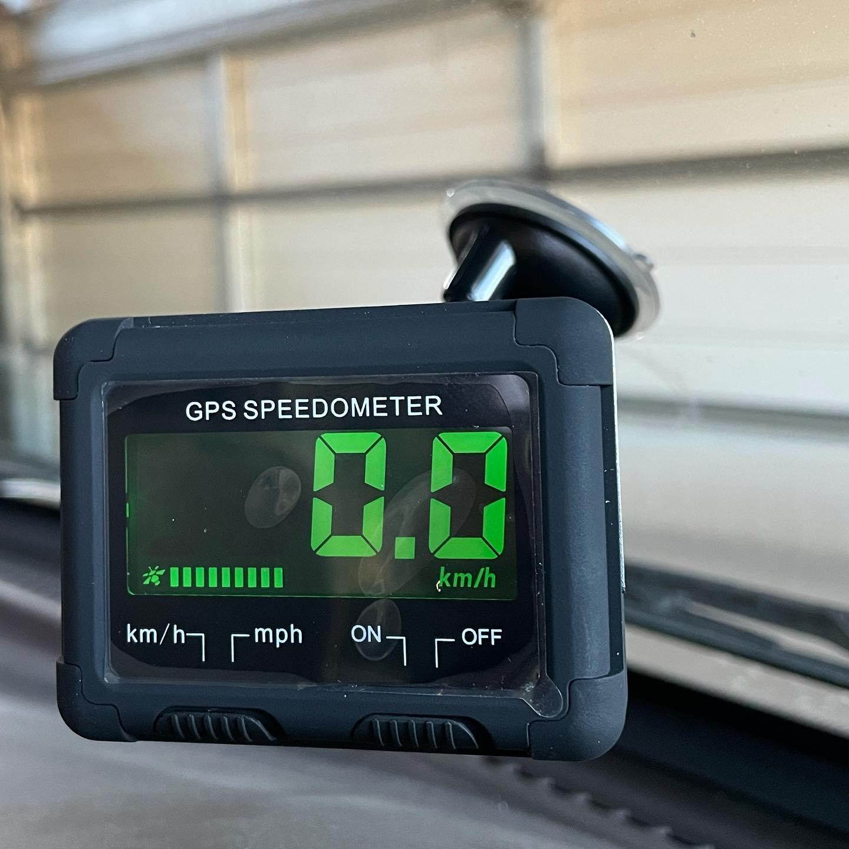
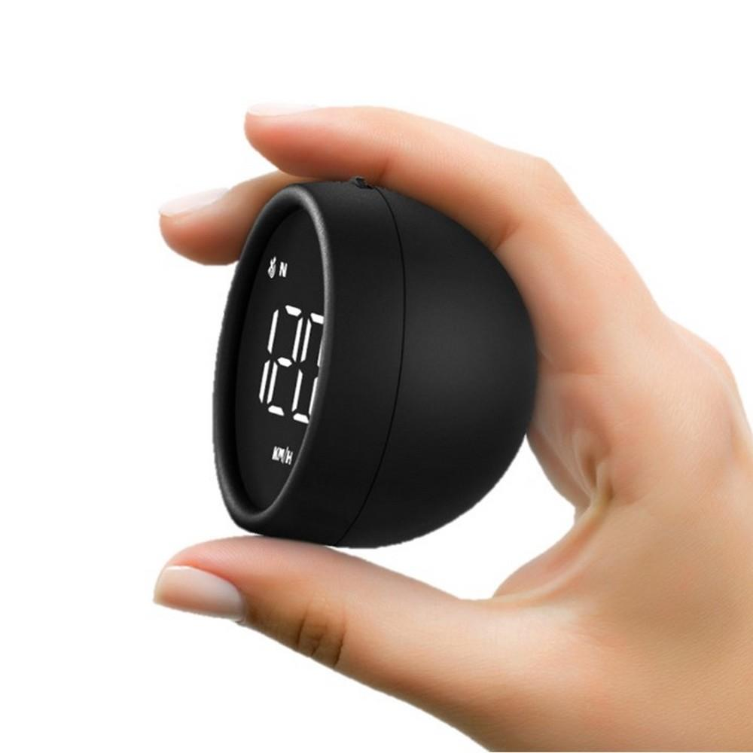
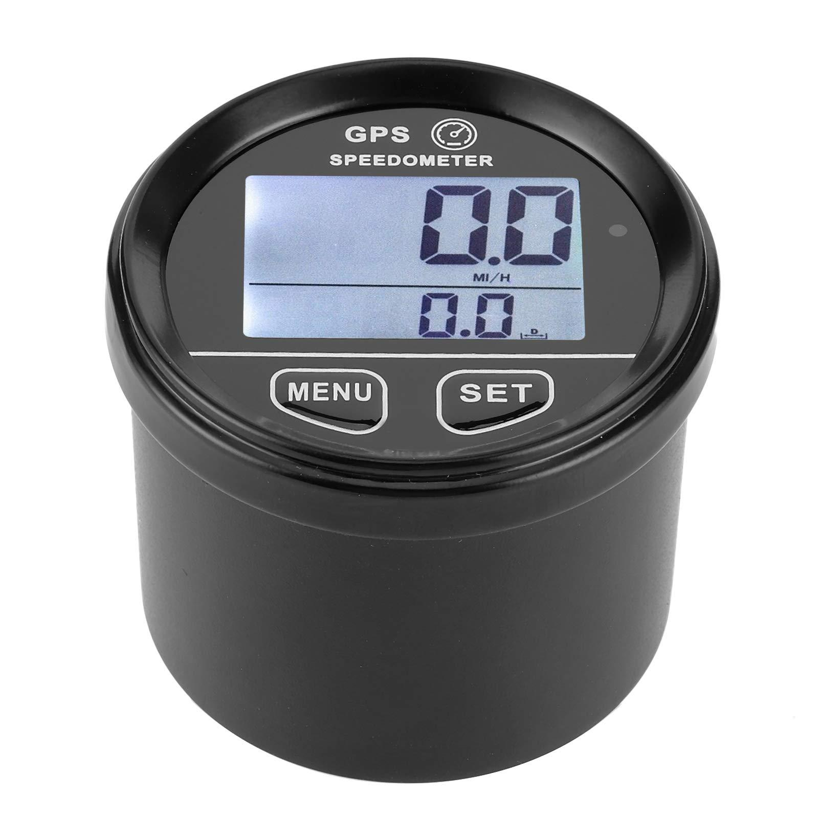
Description
Calculates speed using signals received from GPS satellites instead of wheel or transmission sensors.
Features
- Independent of vehicle sensors
- High accuracy during steady travel
- Portable models available
Applications
- Boats
- Recreational vehicles
- Performance testing
- Navigation

5. Bicycle Speedometer
# Source: AI Source: Provided by: [Data Path: Persons Table -> ID Column: 1, Name_En Column: Motasem Essam] -> From: [ChatGPT] on [7/17/2026]
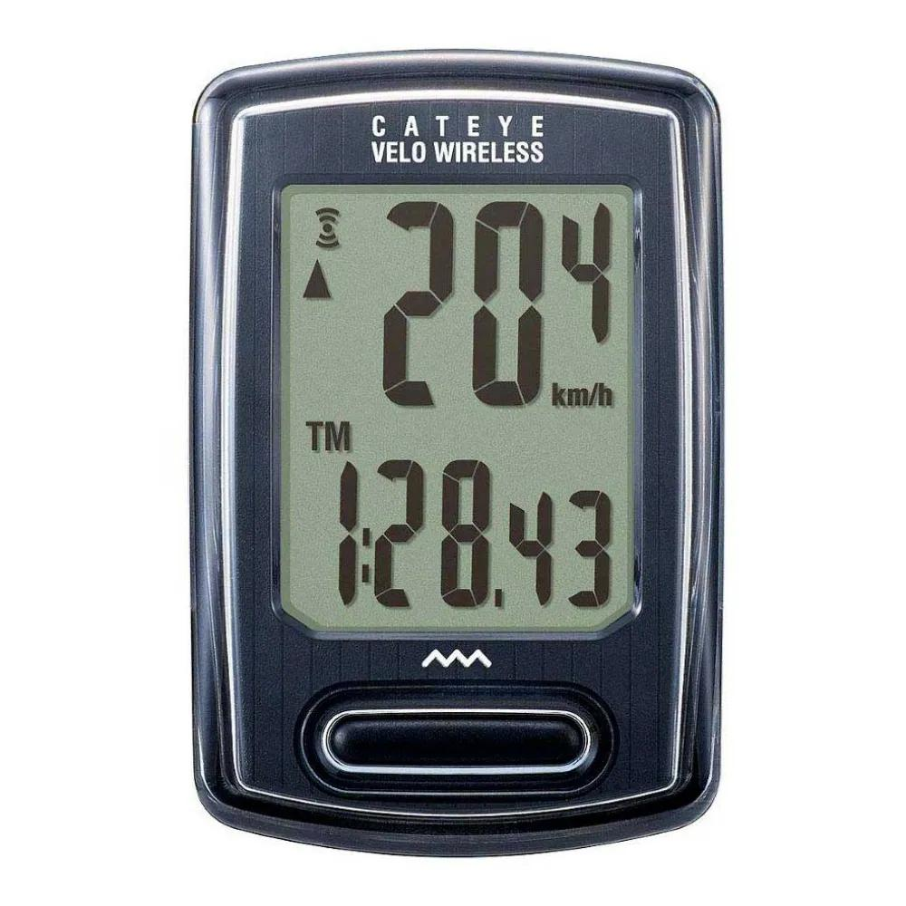
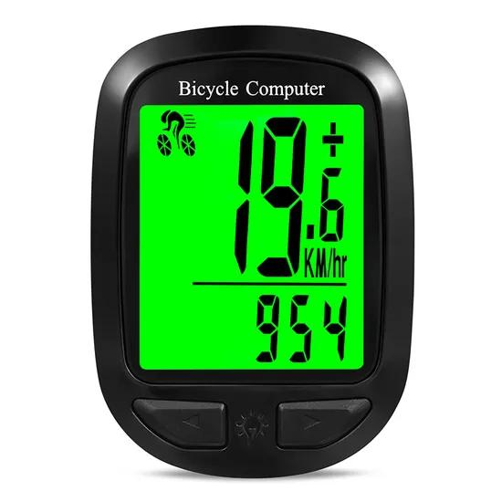
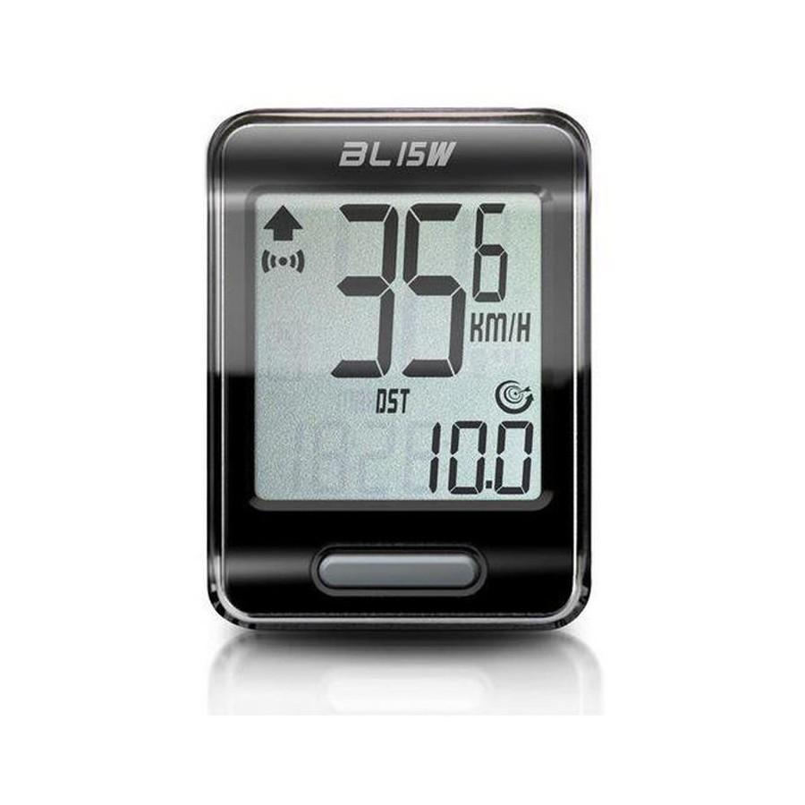
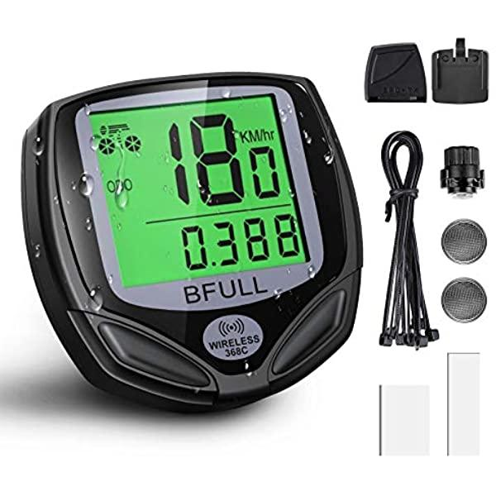
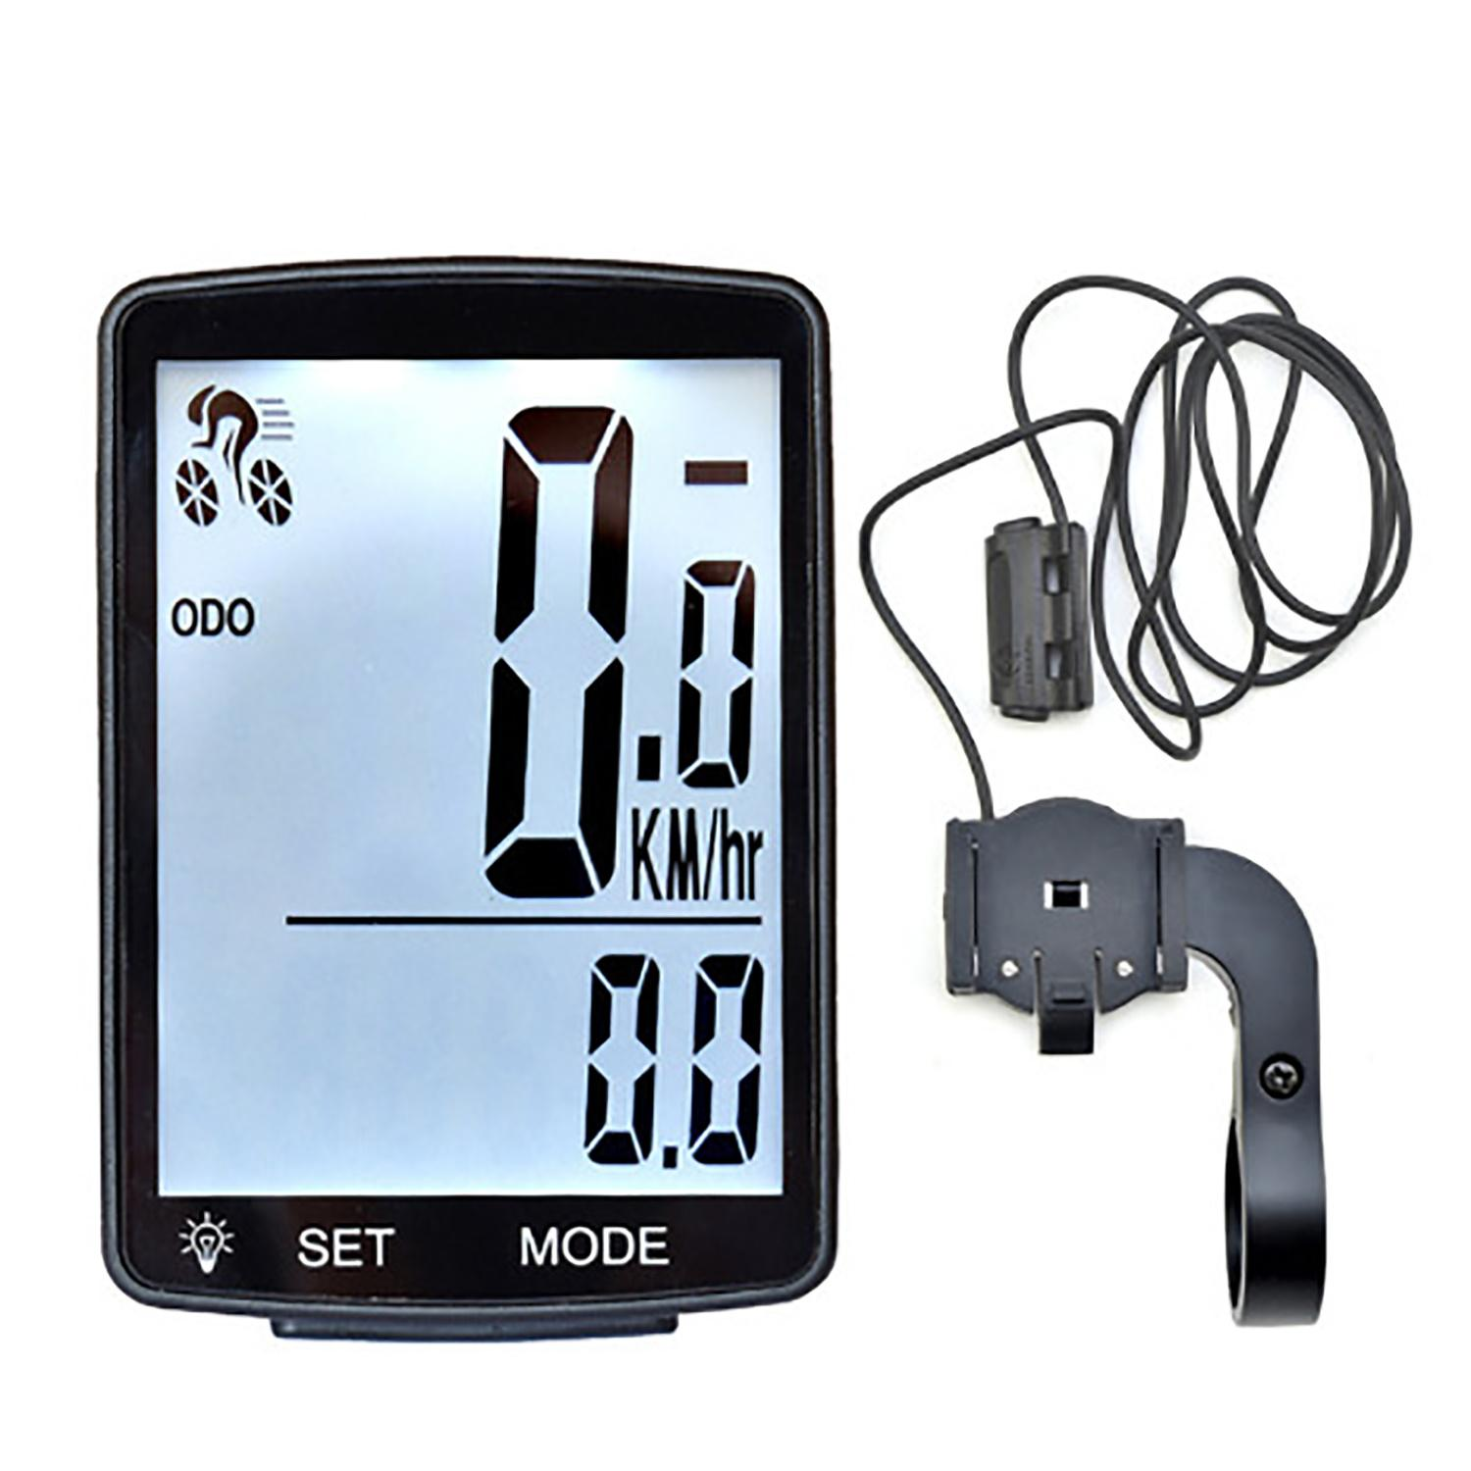
Description
Measures bicycle speed using a wheel-mounted sensor and magnet or GPS technology.
Features
- Compact
- Lightweight
- Often displays speed, distance, cadence, and trip information
Applications
- Recreational cycling
- Fitness
- Competitive cycling

6. Heads-Up Display (HUD) Speedometer
# Source: AI Source: Provided by: [Data Path: Persons Table -> ID Column: 1, Name_En Column: Motasem Essam] -> From: [ChatGPT] on [7/17/2026]
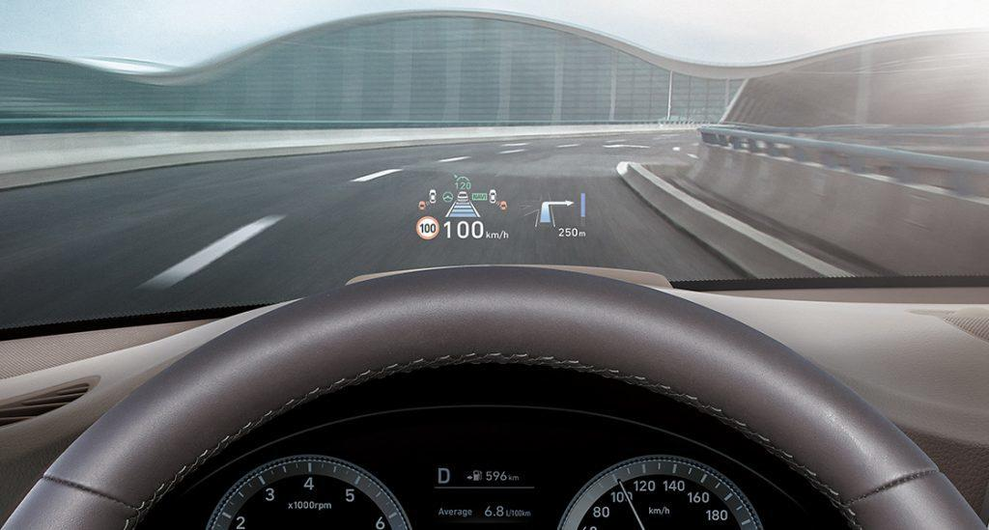
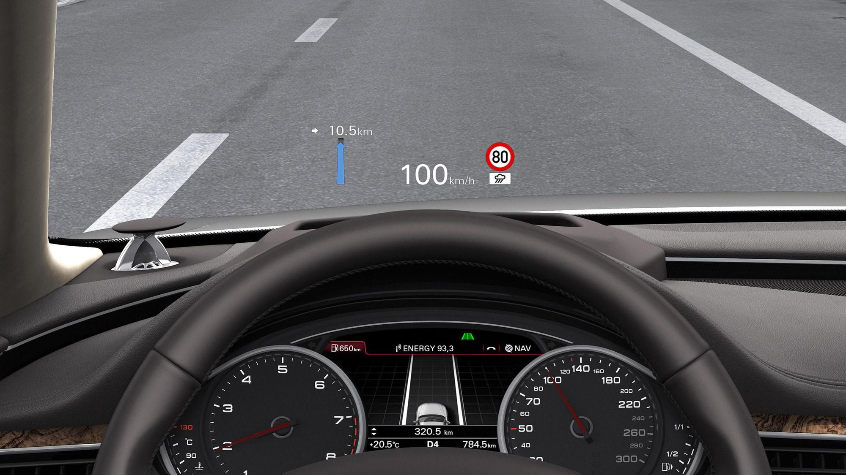
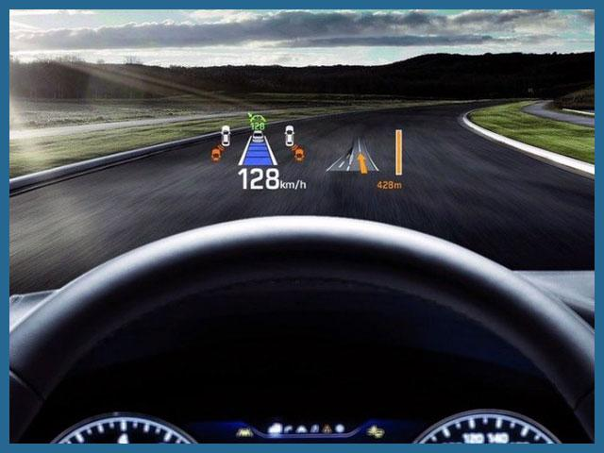
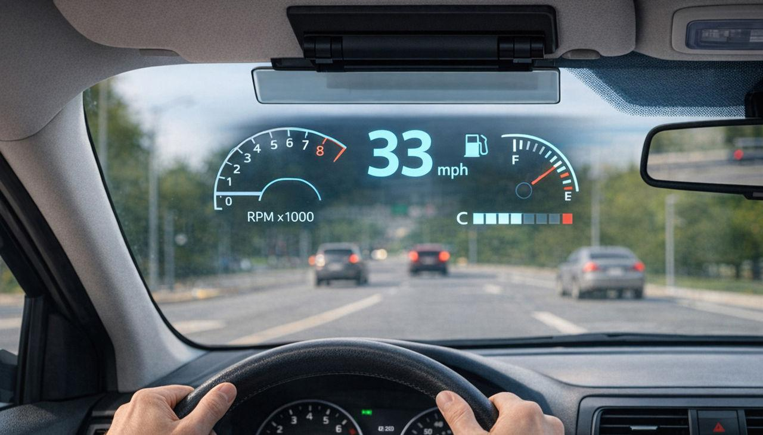
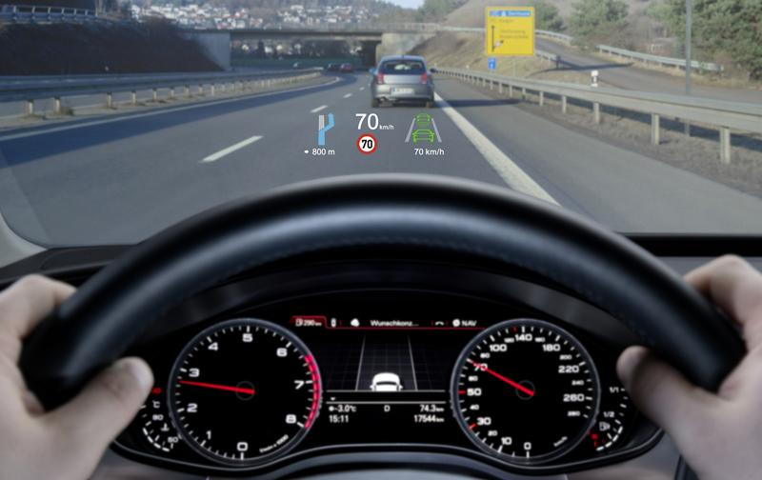
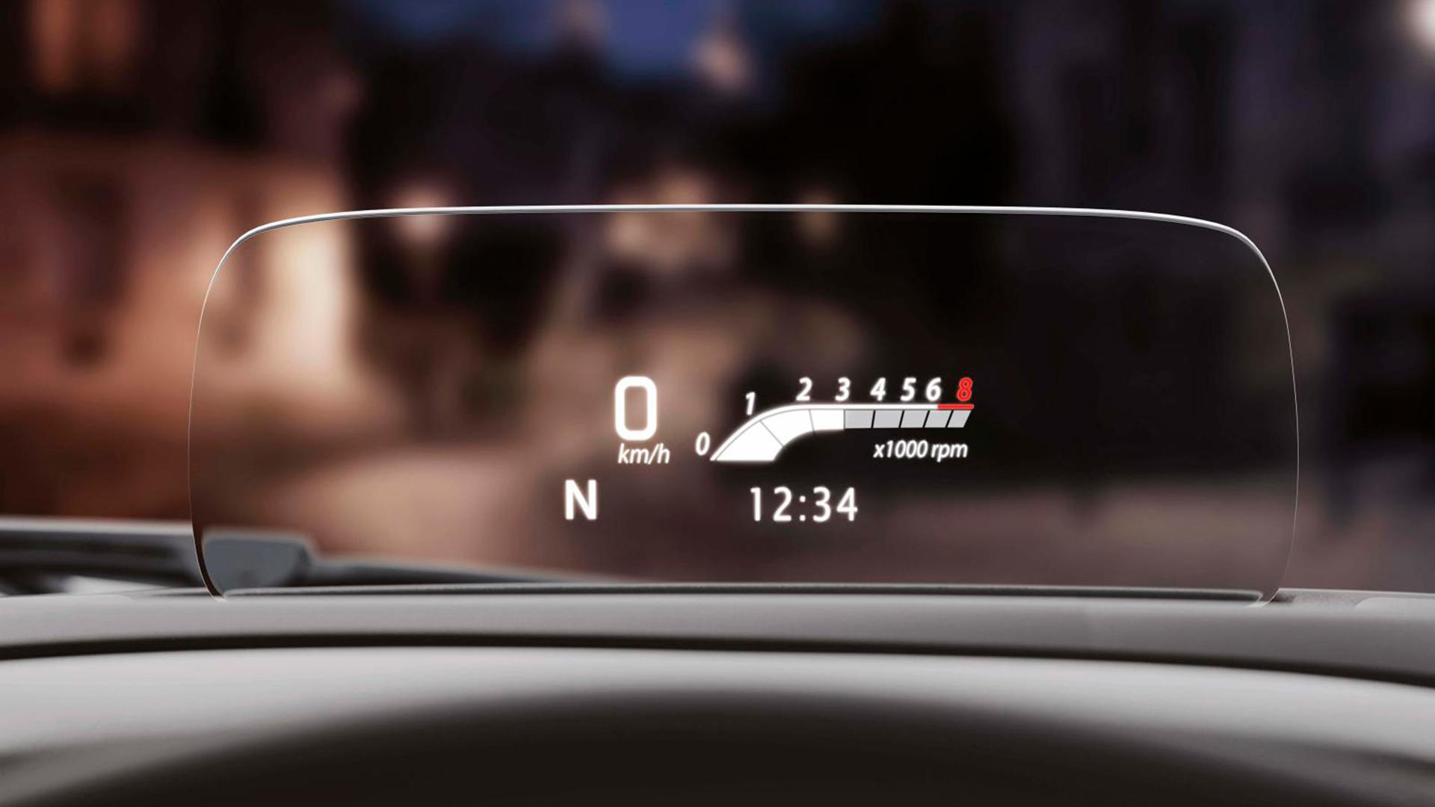
Description
Projects the vehicle's speed onto the windshield or a transparent display, allowing the driver to keep their eyes on the road.
Features
- Windshield projection
- Real-time speed display
- Improved driving safety
Applications
- Luxury vehicles
- Sports cars
- Driver assistance systems

Measuring Units
# Source: AI Source: Provided by: [Data Path: Persons Table -> ID Column: 1, Name_En Column: Motasem Essam] -> From: [ChatGPT] on [7/17/2026]
Speedometers commonly display:
- Kilometers per hour (km/h)
- Miles per hour (mph)
Some specialized instruments may also display:
- Meters per second (m/s)
- Knots (kn) for marine and aviation applications

Measuring Range
# Source: AI Source: Provided by: [Data Path: Persons Table -> ID Column: 1, Name_En Column: Motasem Essam] -> From: [ChatGPT] on [7/17/2026]
The measuring range depends on the vehicle and application.
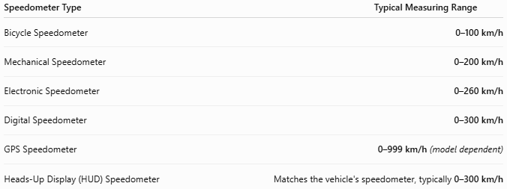
Speedometer Type | Typical Measuring Range
Bicycle Speedometer | 0–100 km/h
Mechanical Speedometer | 0–200 km/h
Electronic Speedometer | 0–260 km/h
Digital Speedometer | 0–300 km/h
GPS Speedometer | 0–999 km/h (model dependent)
Heads-Up Display (HUD) Speedometer | Matches the vehicle's speedometer, typically 0–300 km/h

Resolution
# Source: AI Source: Provided by: [Data Path: Persons Table -> ID Column: 1, Name_En Column: Motasem Essam] -> From: [ChatGPT] on [7/17/2026]
Resolution is the smallest speed increment that can be displayed.
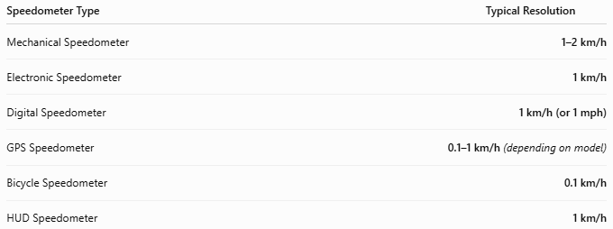
Speedometer Type | Typical Resolution
Mechanical Speedometer | 1–2 km/h
Electronic Speedometer | 1 km/h
Digital Speedometer | 1 km/h (or 1 mph)
GPS Speedometer | 0.1–1 km/h (depending on model)
Bicycle Speedometer | 0.1 km/h
HUD Speedometer | 1 km/h

Accuracy
# Source: AI Source: Provided by: [Data Path: Persons Table -> ID Column: 1, Name_En Column: Motasem Essam] -> From: [ChatGPT] on [7/17/2026]
Accuracy indicates how closely the displayed speed matches the actual speed.
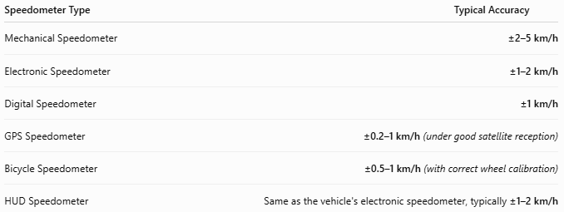
Speedometer Type | Typical Accuracy
Mechanical Speedometer | ±2–5 km/h
Electronic Speedometer | ±1–2 km/h
Digital Speedometer | ±1 km/h
GPS Speedometer | ±0.2–1 km/h (under good satellite reception)
Bicycle Speedometer | ±0.5–1 km/h (with correct wheel calibration)
HUD Speedometer | Same as the vehicle's electronic speedometer, typically ±1–2 km/h
Notes
- Vehicle speedometers are often intentionally calibrated to slightly overestimate speed rather than underestimate it, in accordance with regulations in many countries.
- GPS speedometers generally provide very accurate readings during steady motion but may become less accurate in tunnels, urban canyons, or areas with poor satellite reception.

How to Use a Speedometer
# Source: AI Source: Provided by: [Data Path: Persons Table -> ID Column: 1, Name_En Column: Motasem Essam] -> From: [ChatGPT] on [7/17/2026]
- Start the vehicle.
- Drive normally.
- Observe the displayed speed.
- Compare with posted speed limits.
- Adjust vehicle speed as needed.

Example
# Source: AI Source: Provided by: [Data Path: Persons Table -> ID Column: 1, Name_En Column: Motasem Essam] -> From: [ChatGPT] on [7/17/2026]
The speedometer displays:
80 km/h
Vehicle speed:
80 kilometers per hour

Applications
# Source: AI Source: Provided by: [Data Path: Persons Table -> ID Column: 1, Name_En Column: Motasem Essam] -> From: [ChatGPT] on [7/17/2026]
Speedometers are used in:
- Passenger cars
- Trucks
- Buses
- Motorcycles
- Bicycles
- Boats
- Aircraft
- Racing vehicles

Advantages
# Source: AI Source: Provided by: [Data Path: Persons Table -> ID Column: 1, Name_En Column: Motasem Essam] -> From: [ChatGPT] on [7/17/2026]
A speedometer:
- Provides real-time speed information.
- Improves road safety.
- Helps drivers comply with speed limits.
- Supports efficient vehicle operation.
- Is easy to read during driving.

Limitations
# Source: AI Source: Provided by: [Data Path: Persons Table -> ID Column: 1, Name_En Column: Motasem Essam] -> From: [ChatGPT] on [7/17/2026]
A speedometer:
- May display a slight positive error.
- Depends on correct tire size calibration (vehicle-mounted types).
- GPS models require good satellite reception.
- Mechanical models experience wear over time.

Sources of Error
# Source: AI Source: Provided by: [Data Path: Persons Table -> ID Column: 1, Name_En Column: Motasem Essam] -> From: [ChatGPT] on [7/17/2026]
Instrument Errors
- Sensor malfunction
- Calibration error
- Mechanical wear

User Errors
- Incorrect tire size
- Poor installation
- Ignoring calibration requirements

Environmental Errors
- GPS signal obstruction
- Wheel slippage
- Icy or muddy roads

Comparison with Other Speed-Measuring Instruments
# Source: AI Source: Provided by: [Data Path: Persons Table -> ID Column: 1, Name_En Column: Motasem Essam] -> From: [ChatGPT] on [7/17/2026]
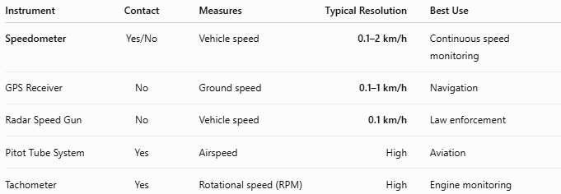
Instrument | Contact | Measures | Typical Resolution | Best Use
Speedometer | Yes/No | Vehicle speed | 0.1–2 km/h | Continuous speed monitoring
GPS Receiver | No | Ground speed | 0.1–1 km/h | Navigation
Radar Speed Gun | No | Vehicle speed | 0.1 km/h | Law enforcement
Pitot Tube System | Yes | Airspeed | High | Aviation
Tachometer | Yes | Rotational speed (RPM) | High | Engine monitoring

Care and Maintenance
# Source: AI Source: Provided by: [Data Path: Persons Table -> ID Column: 1, Name_En Column: Motasem Essam] -> From: [ChatGPT] on [7/17/2026]
To maintain accuracy:
- Ensure proper tire size.
- Inspect speed sensors regularly.
- Keep electronic connections secure.
- Calibrate after major drivetrain or tire modifications.
- Update GPS firmware when applicable.

Common Mistakes
# Source: AI Source: Provided by: [Data Path: Persons Table -> ID Column: 1, Name_En Column: Motasem Essam] -> From: [ChatGPT] on [7/17/2026]
- Assuming the indicated speed is always exact.
- Ignoring tire-size changes.
- Using GPS speedometers in areas with poor satellite reception.
- Confusing speed (km/h) with engine speed (RPM).

Key Points
# Source: AI Source: Provided by: [Data Path: Persons Table -> ID Column: 1, Name_En Column: Motasem Essam] -> From: [ChatGPT] on [7/17/2026]
- A Speedometer measures the instantaneous speed of a moving vehicle.
- Common types:
  - Mechanical Speedometer
  - Electronic Speedometer
  - Digital Speedometer
  - GPS Speedometer
  - Bicycle Speedometer
- Common units:
  - km/h
  - mph
- Modern vehicles primarily use electronic or digital speedometers.
- GPS speedometers provide an independent method of measuring speed using satellite positioning.

Conclusion
# Source: AI Source: Provided by: [Data Path: Persons Table -> ID Column: 1, Name_En Column: Motasem Essam] -> From: [ChatGPT] on [7/17/2026]
A Speedometer is an essential speed-measuring instrument that continuously displays the speed of a moving vehicle. From traditional mechanical systems to advanced digital and GPS-based designs, speedometers play a vital role in safe driving, legal compliance, vehicle performance monitoring, and transportation efficiency. Their ability to provide immediate speed information makes them one of the most important measuring instruments found in modern vehicles.

